**Pre-Color Visualizer for Smart Phone**

FINAL YEAR PROJECT REPORT

2015

NAVEED BALOCH

FARHAN-UL-HAQ KHAN

4/20/2015

**ABSTRACT:**

Every so often people are confronted with the problem of deciding which colors to choose in the direction to paint their walls, doors and ceilings. They are profound to know how their rooms will look like after applying a certain color. Traditionally, there is only one technique to solve this problem, is to actually apply the paint which is an expensive and often irreversible solution.

To overcome this problem, we aspired to design a mobile application that can provide people the opportunity to preview their rooms/walls/ceilings, etc., with a certain color before applying in reality .Through our application the user can click photos of their rooms/walls/ceilings, etc., and change their colors virtually and preview them. This will contribute them a good estimate about the final look of their house.

This app will be convenient for many paint, home renovating professionals, and home owners.

**DECLARATION:**

This declaration is to clarify that all of the submitted contents of this project are original in its figure, excluding those, which have been admitted specifically in the references. All the work process involved is from our own idea and creativity. All contents of this project have been submitted as a part of partial fulfillment. I hereby declare that this project is the work of our own excluded for the references document and summaries that have been acknowledge.

Checked and Approved by

\_\_\_\_\_\_\_\_\_\_\_\_\_\_\_\_\_\_\_\_\_\_\_\_\_\_\_\_\_\_

**Dr. Aarij Mahmood Hussaan**

Project Supervisor

Faculty Of Engineering and Technology

IQRA UNIVERSITY

April 2015

**ACKNOWLEGEMENT:**

First we would like to thank Allah Almighty who helps us to far-reaching this work which is one of his blessings on us and we like to express my gratitude and appreciation to all those who contributed in the possibility to complete this report.

A special thank and heart full gratitude to our final year project supervisor **Dr. Aarij Mahmood Hussaan** whose assistance, stimulating suggestions and encouragement, helped us to complete our project.

Special appreciations goes to my Co-Member, **Farhan-ul-haq Khan** who helps me to assemble the information and contributed his suggestion and his full effort in accomplishing the goal as well as his reinforcement to maintain our progress in track.

Deepest thanks and gratefulness to our parents, family, and others for their cooperation, inspiration, constructive suggestion and full of support for the report completion, from the beginning till the end.

Also thanks to all of our friends and everyone, those have been contributed by supporting our effort and help us all through the final year project advancement till it is fully completed.

**CO-MEMBERS:**

NAVEED – 14921

FARHAN-UL0-HAQ -- 14815

**PREPARED BY:**

NAVEED

**TABLE OF CONTENTS:**

CONTENTS PAGE NO

ABSTRACT …………………………………………...……………………..………… (I)

DECLARATION……………………………………………………………………..… (II)

ACKNOWLEGMENT………………………………………………………………….. (III)

1. INTRODUCTION…….………………………………………………………………..

* 1. SCOPE……………………………………………………….
  2. OBJECTIVS AND GOALS…………………………………
  3. FEATURES………………………………………………….
  4. OVER VIEW OF THE MODEL…………………………..…

1. PROJECT DESCRIPTIONS………………………………………………………….
   1. ENLIGHTENMENT OF THE MODEL……………………
   2. FUNCTIONS PERFORMED……………………………....
   3. TECHNOLOGY USED………………………………….....
   4. USER INTERFACE DESIGN …………………………….
2. IMPLEMENTATION………………………………………………………………….
   1. DELIVERABLE ITEMS
   2. MILESTONES

1. EQUIPMENT VITAL FOR THE PROJECT………………………………………….
2. CONCLUSION…………………………………………………………………………
3. REFERENCES…………………………………………………………………………

**1. INTRODUCTION:**

This project use the android platform to build an application where a customer can have prospect to preview their rooms/walls/ceilings, etc., with a certain color before applying in reality. This application allow you to upload a photo of the room you plan to paint, then apply different paint colors to the walls with a simple drag and drop action. Implementation of this model transpires by using android phone and desktop computer.

**Color is the place where our brain and universe meet.**

**By: Paul Klee**

Paint cooler ideas to unleash your creativity with a world of colors for your room or house. Color trends, color schemes, color palettes and more.

# SCOPE:

This App can be used by Home owners, Color shops, under construction buildings because of time-saving and productivity benefits. This apps work on android platform and you can run it on any android device.

It is also very effective for Paint industry for showing the customers the effects of their paint on the houses in real-time. This application can also be used as color visualizer.

# OBJECTIVES AND GOALS:

* To allow homeowners to pre-visualize the effects of applying different colors on their walls, doors, ceilings, etc.
* To achieve the aforementioned goal using a mobile application objectives.
* To be able to identify different objects automatically using static images.
* To be able to change colors of the identified objects.
* To change colors keeping into account the light variations.

# FEATURES:

Some of the features of this application are for user interface and easy to handle the application.

* Detection of different objects (walls, doors, ceilings, etc.) in an automatic manner.
* Ability to choose colors from a variety of different option and apply them to the detected objects.
* Ability to apply colors according to the light intensity for more realistic visualization.

# OVERVIEW OF THE MODEL:

This is a visualizer plan or road map; it helps to determine how a person can use this application easily and effectively, which zone he desire to renovate just click a picture of it and segmented the zone according to the choice, formerly select a specific color for that area and decide after preview result. It’s a good tool to help a customer to select a desirable result according to the thoughts and ideas.

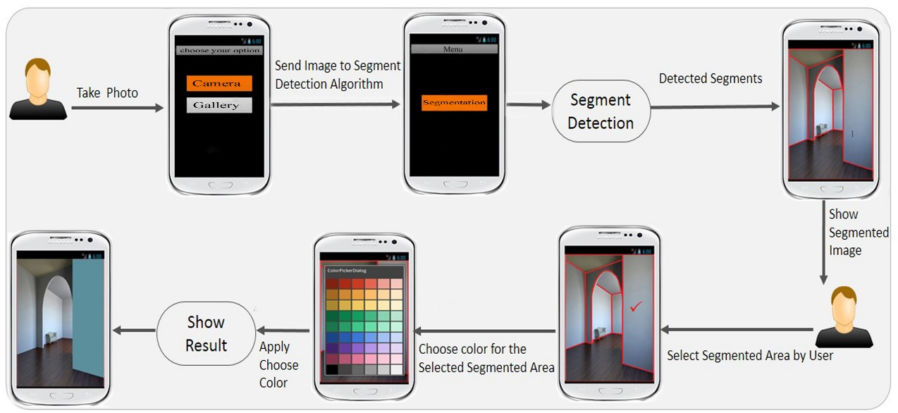

# 2. PROJECT DESCRIPTIONS:

# 2.1. ENLIGHTENMENT OF THE MODEL:

This representation and rules are for expressing the conceptual and implementation architectures of this application. Application software cannot run on itself but is dependent on system software to execute.

1. User will either take a photo from his/her smartphone or select an image from the phone’s gallery.
2. The image is then sent to our detection engine
3. The detection engine will detect the different objects from the image
4. The detected segments will be shown to the user
5. The user will select a segment and a color from the provided color pallet
6. Finally, our app will apply the chosen color of the selected segment taking into consideration the light variations.
7. And the user will have the same image but with the colors s/he wanted.

# 2.2. FUNCTIONS PERFORMED:

# 2.3. TECHNOLOGY USED:

Multiple technologies are used to develop this application and create its user interface and other functions of this application.

# 2.3.1. ECLIPSE (KEPLER 4.3)

Eclipse is an [integrated development environment](http://en.wikipedia.org/wiki/Integrated_development_environment) (IDE). It contains a base [workspace](http://en.wikipedia.org/wiki/Workspace) and an extensible [plug-in](http://en.wikipedia.org/wiki/Plug-in_(computing)) system for customizing the environment. Written mostly in [Java](http://en.wikipedia.org/wiki/Java_(programming_language)), Eclipse is used to develop applications. Development environments include the Eclipse Java development tools (JDT) for Java and Scala, Eclipse CDT for C/C++ and Eclipse PDT for PHP, among others.

Eclipse uses plug-ins to provide all the functionality within and on top of the runtime system. Its runtime system is based on [Equinox](http://en.wikipedia.org/wiki/Equinox_(OSGi)), an implementation of the [OSGi](http://en.wikipedia.org/wiki/OSGi) core framework specification.

Eclipse implements the [graphical control elements](http://en.wikipedia.org/wiki/Graphical_control_element) of the Java toolkit called [SWT](http://en.wikipedia.org/wiki/Standard_Widget_Toolkit), whereas most Java applications use the Java standard [Abstract Window Toolkit](http://en.wikipedia.org/wiki/Abstract_Window_Toolkit) (AWT) or [Swing](http://en.wikipedia.org/wiki/Swing_(Java)). Eclipse's user interface also uses an intermediate [graphical user interface](http://en.wikipedia.org/wiki/Graphical_user_interface) layer called [JFace](http://en.wikipedia.org/wiki/JFace), which simplifies the construction of applications based on SWT.

# 2.3.2. JAVA SDK (SDK VERSION 8):

Java SDK is used to create and modify java programs. It is a development environment for building applications, applets, and components using the Java programming language.

It includes tools useful for developing and testing programs written in the Java programming language and running on the Java platform.

# 2.3.3. ANDRIOD SDK(SDK 22.04)

Android software development is the process by which new applications are created for the [Android operating system](http://en.wikipedia.org/wiki/Android_(operating_system)). Applications are usually developed in [Java](http://en.wikipedia.org/wiki/Java_(programming_language)) programming language using the Android [Software Development Kit](http://en.wikipedia.org/wiki/Software_Development_Kit) (SDK). It includes a comprehensive set of development tools. The SDK also supports older versions of the Android platform in case developers wish to target their applications at older devices. Development tools are downloadable components, so after one has downloaded the latest version and platform, older platforms and tools can also be downloaded for compatibility testing.

# 2.3.4. OPENCV 2.4.6:

OpenCV is released under a BSD license and hence it’s free for both academic and commercial use. It has C++, C, Python and Java interfaces.  OpenCV was designed for computational efficiency and with a strong focus on real-time applications. Written in optimized C/C++, the library can take advantage of multi-core processing. Enabled with OpenCL, it can take advantage of the hardware acceleration of the underlying heterogeneous compute platform.

# 2.3.5. OPENCV (2.4.6) FOR ANDROID:

OpenCV4Android SDK package enables development of Android applications with use of OpenCV library.

# 2.4. USER INTERFACE DESIGN:

User interface designs are illustrated by some screen shots for proper demonstration step by step,  
  
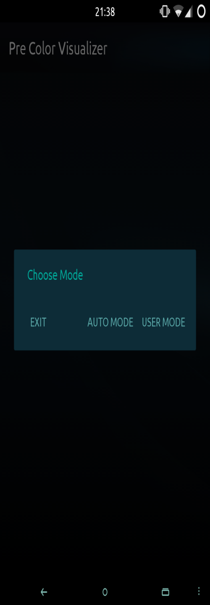 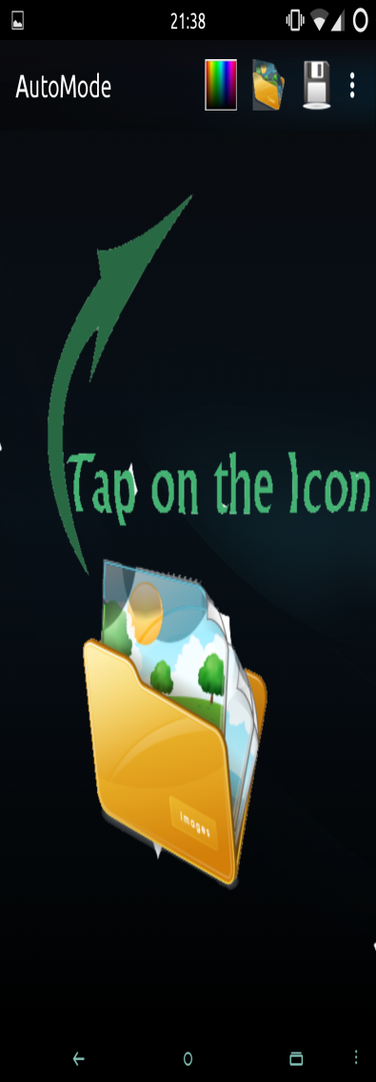 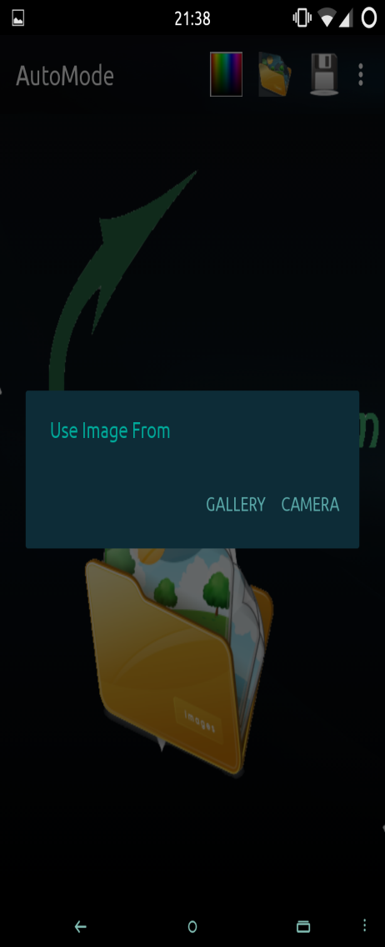

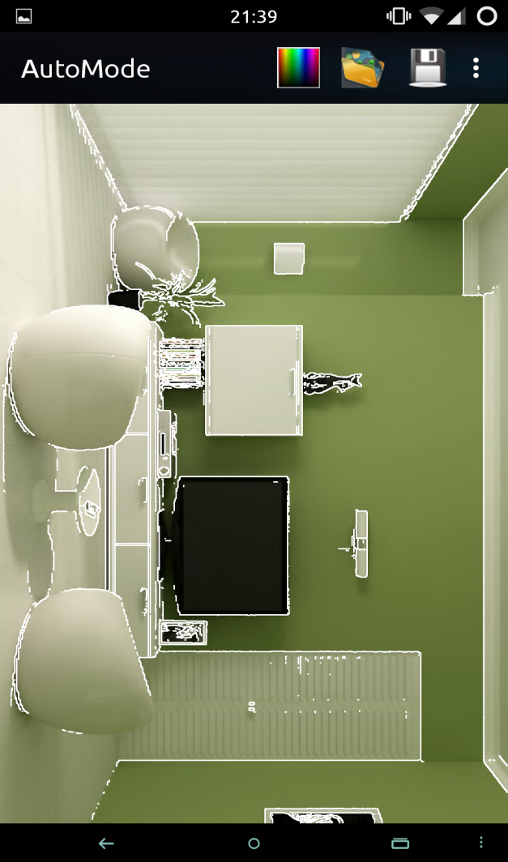 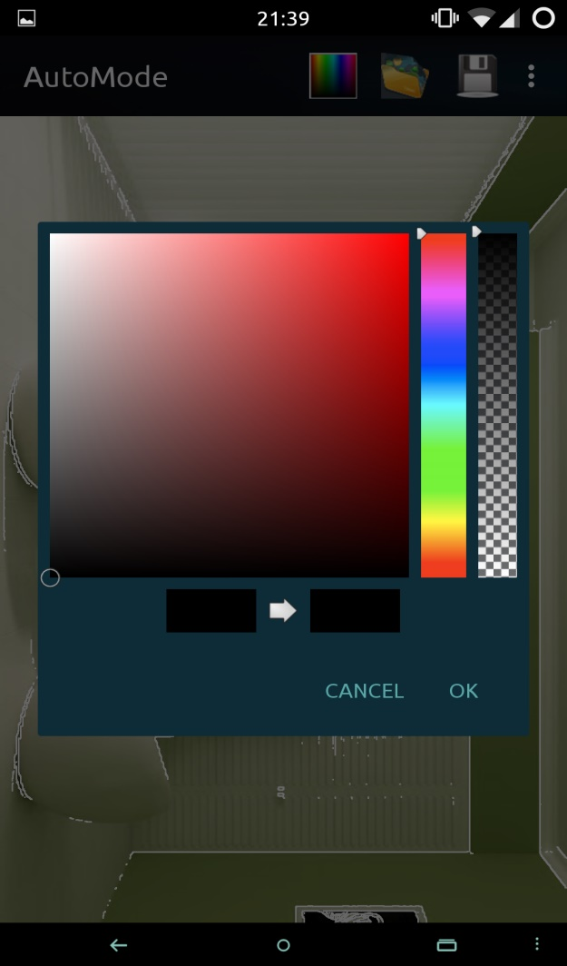

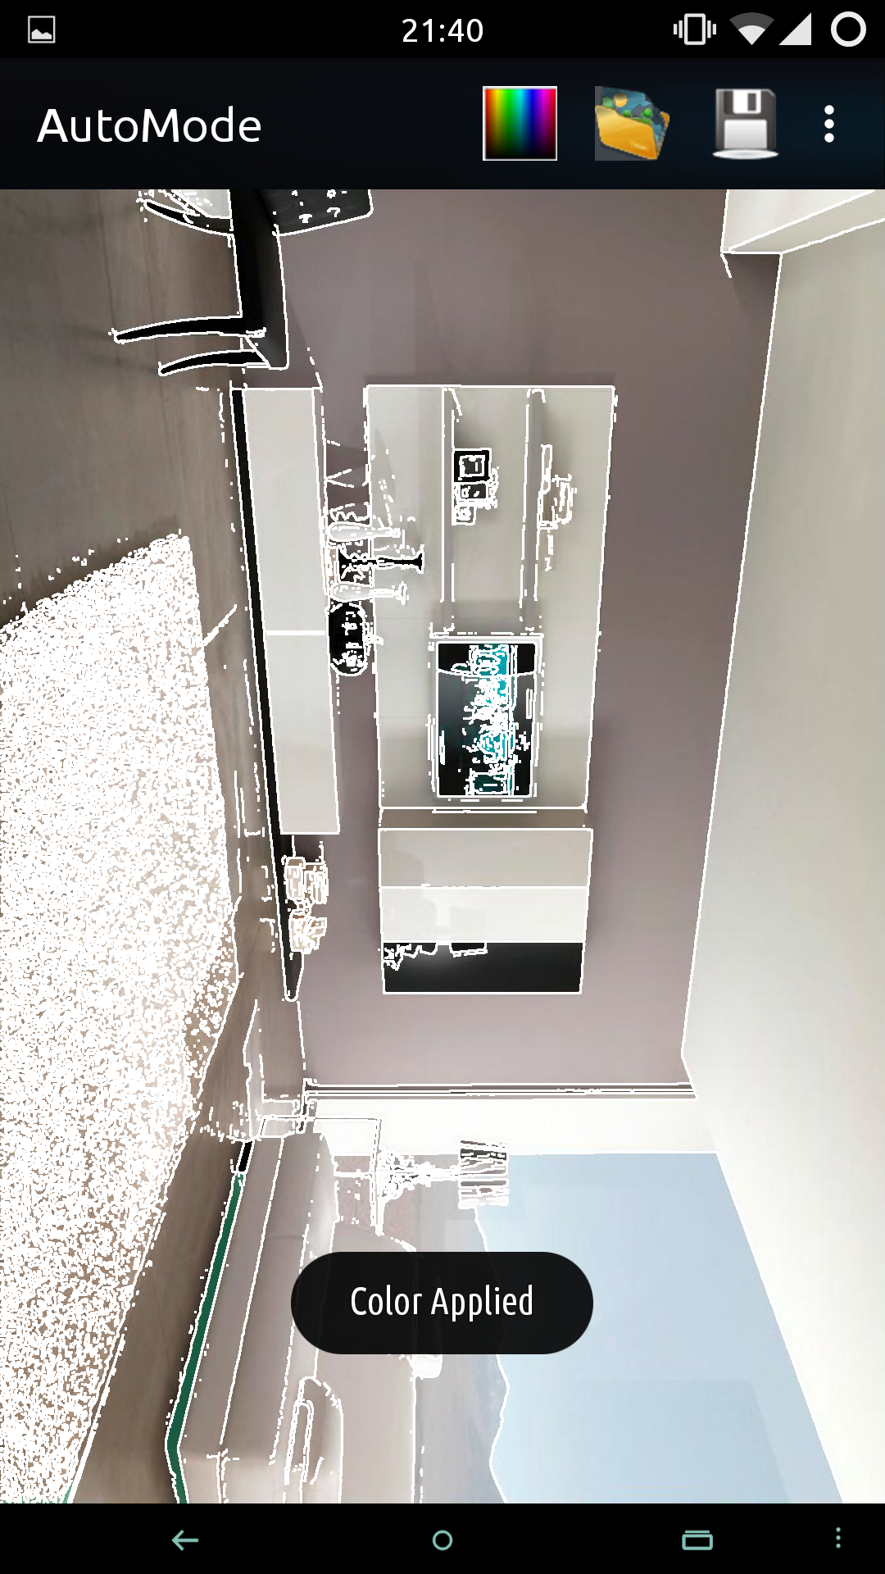

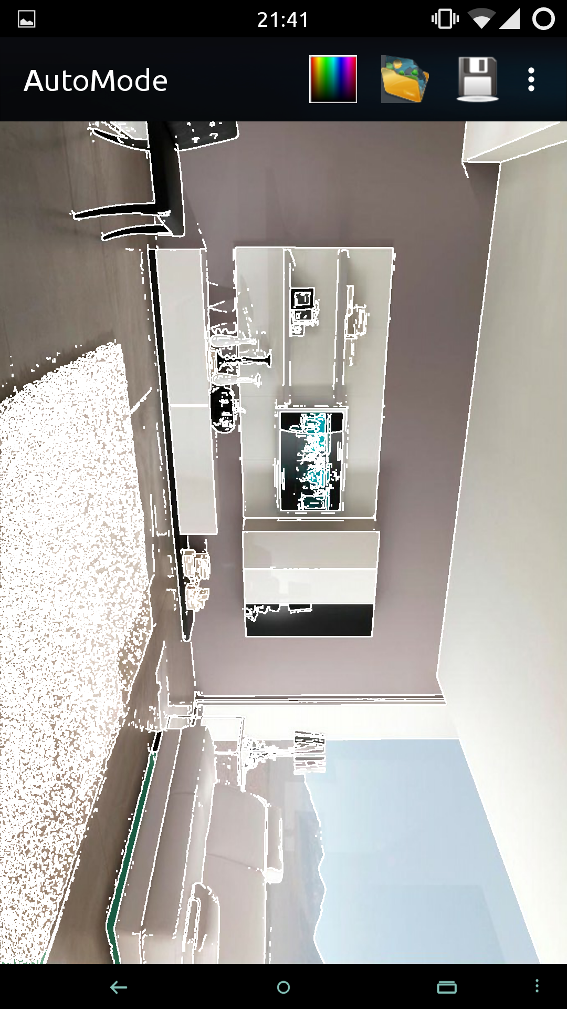

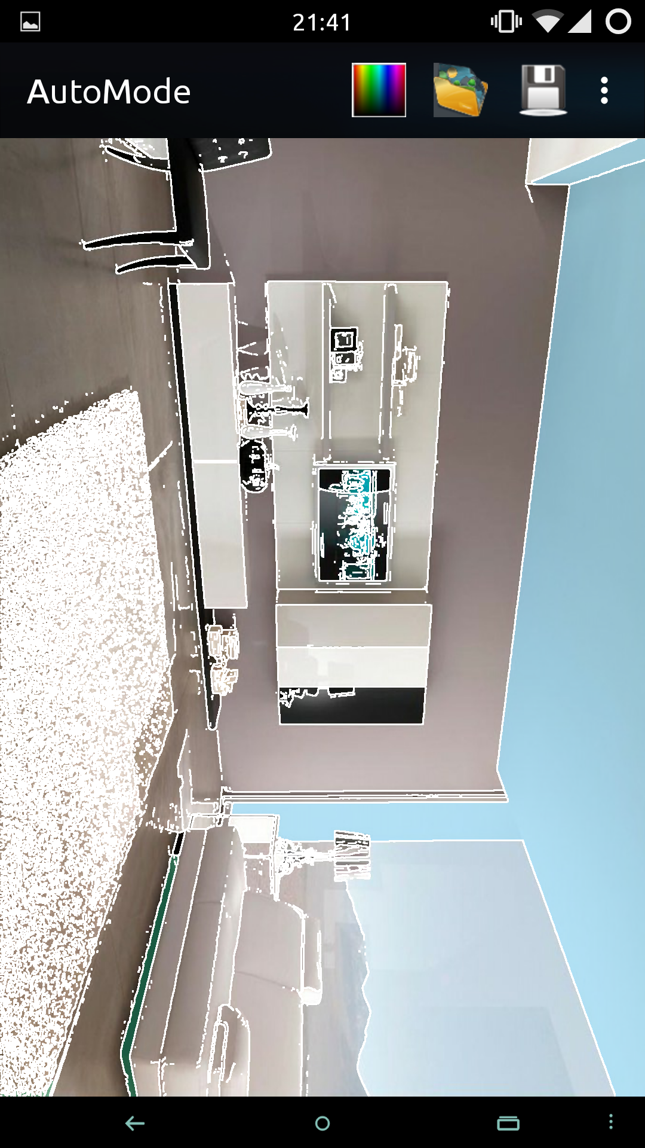

# C:\Users\Iqra\AppData\Local\Microsoft\Windows\INetCache\Content.Word\Screenshot_2015-04-09-21-41-39.png

# C:\Users\Iqra\AppData\Local\Microsoft\Windows\INetCache\Content.Word\Screenshot_2015-04-09-21-41-46.png

# C:\Users\Iqra\AppData\Local\Microsoft\Windows\INetCache\Content.Word\Screenshot_2015-04-09-21-41-46.png

# C:\Users\Iqra\AppData\Local\Microsoft\Windows\INetCache\Content.Word\Screenshot_2015-04-09-21-43-15.png

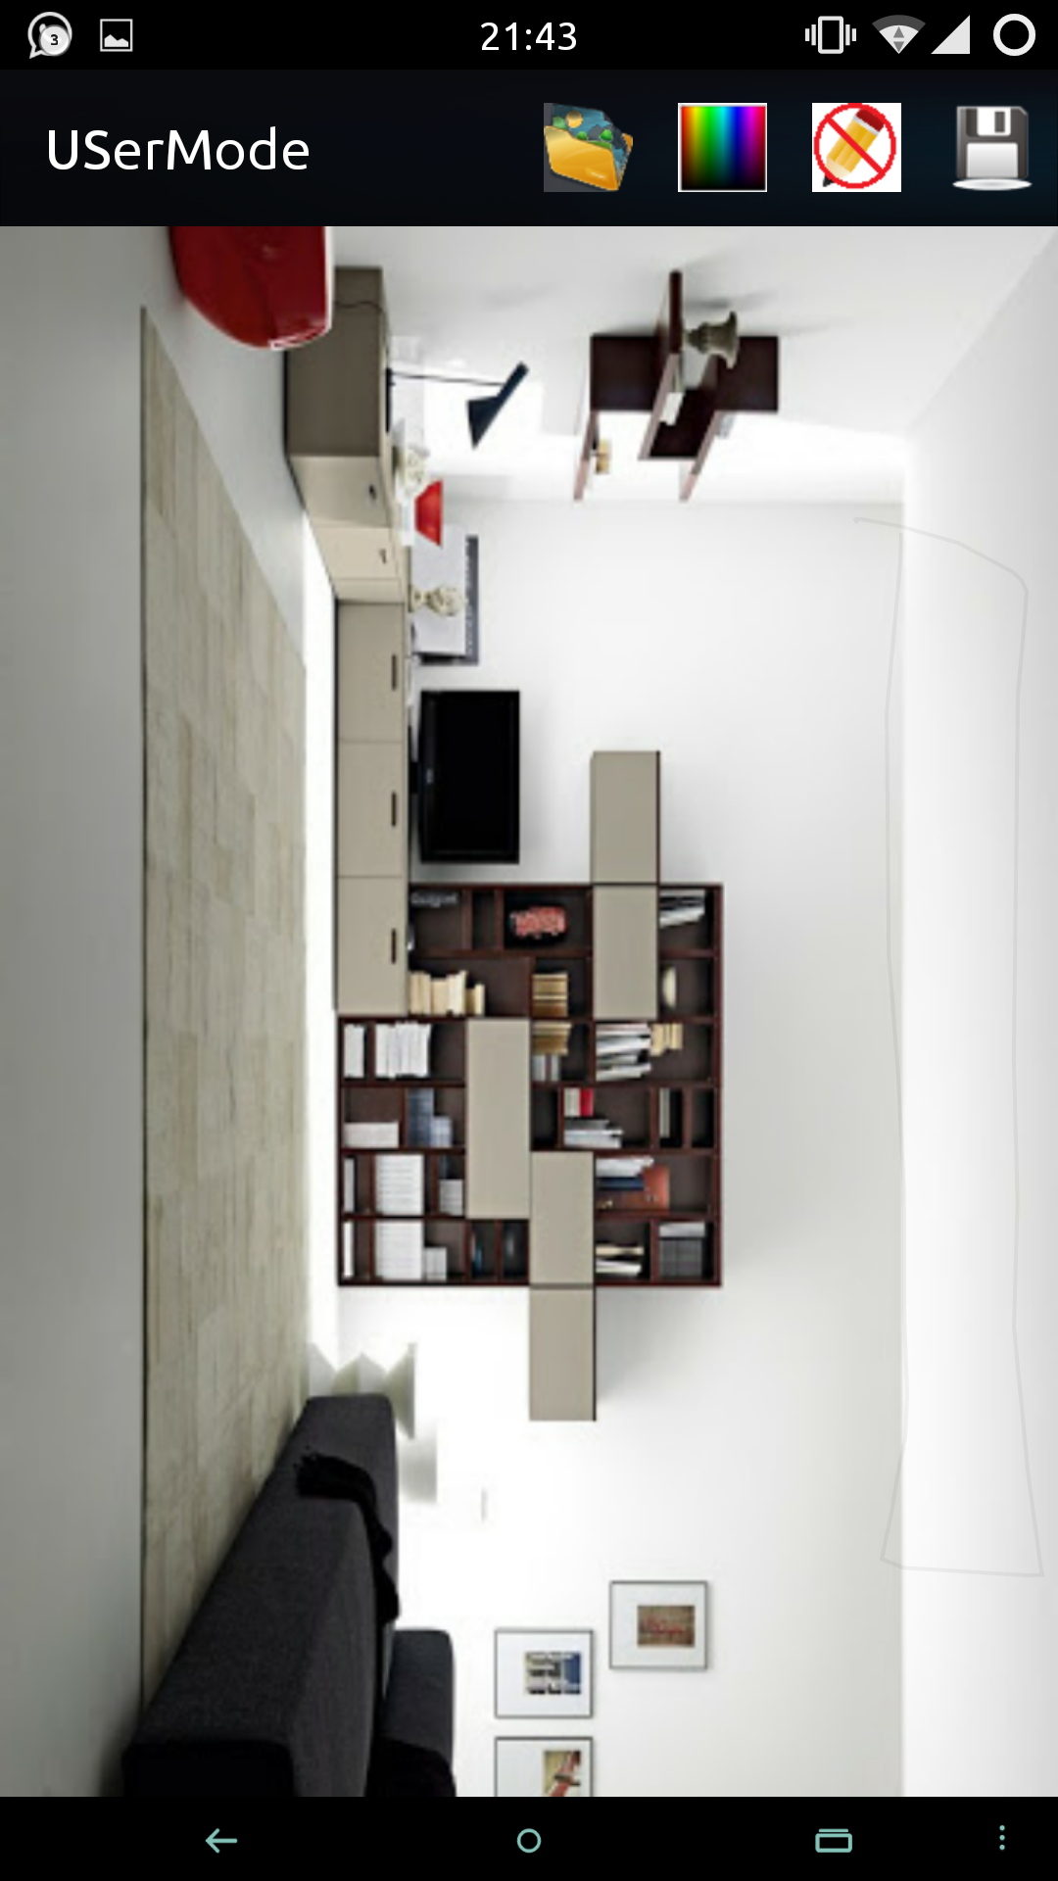

# 3. IMPLEMENTATIONS:

# 3.1. DELIVERABLE ITEMS

* + - * + Project Report
        + Software Requirement Specification
        + UML

Use Case Diagrams

Class Diagrams

Sequence Diagrams

Activity Diagram

* + - * + DFDs
        + Software Architecture
        + Software (Package file)

# 3.2. UML

|  |
| --- |
| **MainActivity** |
| + DialogInterface : builder  + Tag : String  - Intent : UserMode  - Intent : UserMode |
| + onCreate()  + startActivity() |
| Executes when app starts and shows the pop-up/alert dialog to the user which getting input from the users to which mode they wants to go. |

|  |
| --- |
| **MainActivity** |
| + DialogInterface : builder  + Tag : String  - Intent : UserMode  - Intent : UserMode |
| + onCreate()  + startActivity() |
| Executes when app starts and shows the pop-up/alert dialog to the user which getting input from the users to which mode they wants to go. |

|  |
| --- |
| AutoMode |
| + imageView : backView  + imageView : frontView  + Tag : String  - Intent : UserMode  - Intent : UserMode |
|  |
|  |

# 3.2. MILESTONES

# (TODO FOR FARHAN)

# 4. EQUIPMENT VITAL FOR PROJECT:

Some of these equipment’s are vital for the project such as

* Android Mobile
* 1 Desktop Computer
* Core i5
* RAM 8GB
* 250 GB Hard Drive

# 5. CONCLUSION:

It is very effective for Paint industry for showing the customers the effects of their paint on the houses in real-time. It is also very useful to the any person confronted with the problem of deciding which colors to choose in the direction to paint their walls, doors and ceilings. .Through our application the user can click photos of their rooms/walls/ceilings, etc., and change their colors virtually and preview them. This will contribute them a good estimate about the final look of their house.

Some other benefits of the project:

* Pre-visualization of your painted walls, ceils etc.
* This tool will be helpful for pre planning of a room.
* An indispensable tool for construction workers, engineers, architects, carpenters, real estate agents, auction sellers, ...

# 6. REFERENCES:

1. <http://forum.xda-developers.com/showthread.php?t=1722325.com%252Fshowthread.php%253Ft%253D1722325%3B514%3B800>
2. <http://www.clker.com/clipart-14899.html>